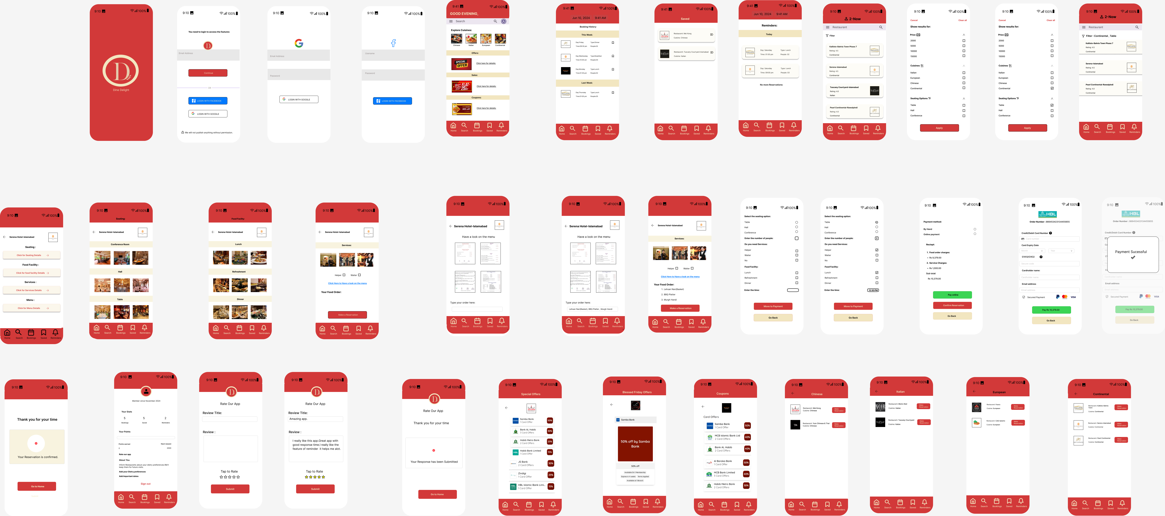

**Figma link:**

https://www.figma.com/design/lKM9ZIjakwDuhlOGzmg8BJ/Dine-Delight-Restaurant-Reservation-App?node-id=0-1&p=f&t=CPmdxlFyl5XyDNFo-0